Computer Graphics

Lab#5

Ramy Ahmed El Sayed

19015649

# Problem Statement

# You are required to implement an application that draws a 3-legged stool as shown in figure 1. For the legs, first create one in a display list and then draw it three times rotated appropriately using appropriate transformation.

Your application should handle user input at runtime as follows:

* When user presses ‘x’ / ‘X’. the 3-legged stool should rotate around x-axis in CW/CCW manner respectively.
* When user presses ‘y’ / ‘Y’. the 3-legged stool should rotate around y-axis in CW/CCW manner respectively.
* When user presses ‘z’ / ‘Z’. the 3-legged stool should rotate around z-axis in CW/CCW manner respectively.
* A picture containing furniture, stool, seat, table

  Description automatically generatedWhen user presses ‘space’. Toggle drawing mode of the 3-legged between drawing a wireframe object or a solid one.

You can use code in [display list and transformation](https://gist.github.com/BassamMattar/0f11588ff47e846463502770f7efbe96) as reference.

# Code Description

The code is divided into two main phase:

* Setup Phase
* Loop Phase

## Setup Phase

The code sequence proceeds as follow:

* Initialize two display lists: the seat and the legs.
* In the first display list, a seat is created using two disks and a cylinder.
* In the second display list, a leg is created using cylinders.

## Loop Phase

The loop starts by specifying the drawing type depending on user input.

Then we build our chair using a hierarchical by using the MODEL_VIEW_MATRIX.

# Example Of Running Code

## Main Screen

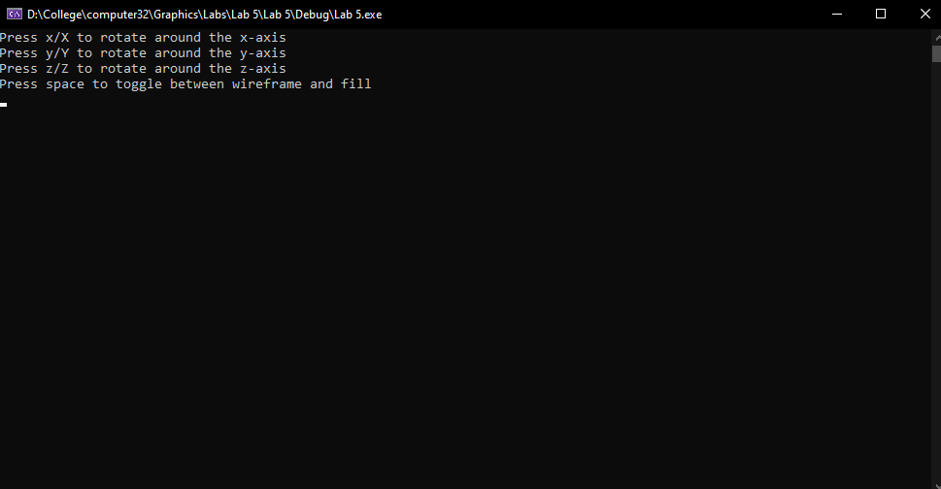

## CHAIR

# Challenges

The main challenge was to build a hierarchical model out of the chair .